Document A

Thomas Rowe Affidavit

Original Transcription
Thomas Row (or Rowe) worked for the British Customs Service in the town of Salem, of the Massachusetts Bay Colony. The British Customs Service was responsible for enforcing laws, including the Sugar Act, and collecting taxes (also known as duties). In September of 1768, Thomas Row reported a group of colonists secretly removing molasses from a ship to avoid paying taxes. The following day he was dragged to the Salem Common and violently attacked by a mob of outraged men. The mob included Richard Derby, his son, Elias Hasket Derby, and his son-in-law, George Crowninshield. This is Row’s statement to the Customs Service in Boston, describing his assault.

(Page 1)
Copy of Thomas Row’s Affidavit concerning the insult he
received from the Mob at Salem.

I Thomas Row Tidesman in the Service
of His Majesty’s Customs at Salem & Marblehead
declare, and am ready to make oath, That –
on the 7th instant, being stationed upon duty at
Salem onboard the Brig Union Samuel Grant
Master from Martinico – and having unloaded
40 hogsheads of molasses into a sloop alongside
in the Channel, to lighten the Vessel, it was
found necessary as the Brig was war?ing in
to get to a wharf to cast off the sloop, which
was accordingly done, and she was moved to
a wharf out of my sight the Tide being so much
fallen that the Brig got aground, and could
not follow her – After fastening the hatches
of the Brig with the Kings Locks, and ???
the Sloop with the 40 hogsheads onboard, in
passing by the wharfs I heard the noise of ???
going, and saw a cask hoisting over the side of
a Schooner, which I reported immediately to
Mr. Savage Landwaiter, weigher, & Gauger, of
the Port, who was then in Bed, but rose very
soon and accompanied me near the place,
where we stood for some time, listening & could
plainly discover that Goods were unshipping
from a Schooner, whereupon Mr. Savage gave
immediate notice thereof to Mr. Moses, the
person stationed for that Vessel, and sent him
down to prevent the Goods being landed –
After this I returned to my station onboard
the

(Page 2)
the Brig, and remained onboard till sun rising
in the morning, when I went on shore to visit
the Sloop with the 40 hogsheads onboard, and
removed her from the place where she ^{then} to
another Wharf – Between nine and ten in
the morning still being on board the Sloop –
a number of Sailors came onboard & forcibly
dragged me from thence to the Common, where
I was kept for the space of an hour, during which
time Henry Gardener Merchant of Salem
waxed the hair of my head with Balls of
Shoemakers Wax, and some amongst them
(I cannot say which) cut part of it off from
behind, then they divided ^{then} into two parties, one
of which went in quest of Mr. Savage & Mr.
Wood to inquire after the Author of the information,
the other carrying me to the Tree of Liberty,
and forced me to sit down under it for half
an hour – I was then marched by them to
seek for the other party, who were met with &
joined at the corner of Judge Lion’s house, headed
by Joseph Moses & Capt.n Lambert from whence they
proceeded with me a second time to the Common,
stripped off my Coat, Waistcoat, handkerchief &
hat tied my hands to a long pole & tarr’d me
all over, they afterwards put me in to a Cart,
my hands being still tied, and fixed two boughs
with spun yarn on each side of my head,
then I was stuck with feathers quite full over
my face, Head, Shirt, and trousers; but finding
the pole hindered the Cart from moving my
hands

(Page 3)
hands were loosened from it, and one hand tied
to the side of the Cart and the other to my Thigh
in this miserable condition was I dragged along
by the Mob from the Common into the main street
where they put a cross made with sticks into
my hand, struck me several violent blows on
my head, and swore they would murder me
if I did not carry it upright – after which
I was again dragged through the street to
the house of Joseph Cabbet, who handed two
papers to the populace with the word Informer
wrote in Capitals which they pinned to my head
??? before and behind – in this shameful
manner I was conducted through the streets,
a live goose being repeatedly thrown at me,
and they stopped the Cart at the houses of
Mr. Turner, Mr. Dowse, Capt. Grant and the
Custom house, at each of which they gave
three cheers crying out that I was an
Informer then I was carried out of the Town
taken out of the Cart, unbound, and set at liberty
George Crowninshield pushing me by the
nip of my neck and said that if I returned to
that Town again I should loose my life.
And I further declare that Capt Lambert
Henry Gardner & George Crowninshield were
the principle directors & abettors of this Savage
brutality.
Thomas T Row
his mark
Castel William
Boston Harbour Witness to Mr. Rows mark
9th. Sept. 1768. Richard ?ewe
D Lisle

Document A
(Page 3 of 3)

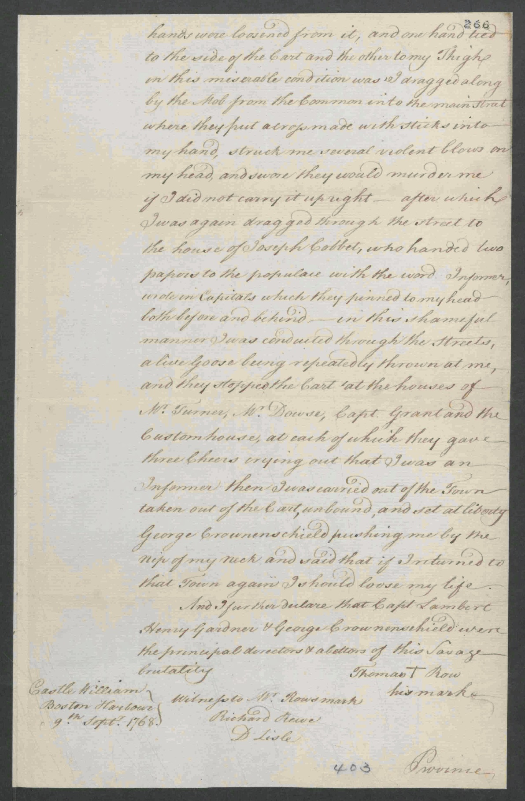
Image Source
The National Archives, United Kingdom. Copy of Thomas Row(e)'s Affidavit concerning the insult he received from the Mob at Salem. Dated Castle William, Boston Harbor, September 9, 1768. T 1/465/265-266.

Document B

Obed’s Broadside Advertisement

Original Transcription
Historically, broadsides were announcements, news, proclamations, or advertisements printed on one side of a larger piece of paper and posted to spread information to the public.
Richard Derby was a ship captain, distillery owner, and wealthy Salem merchant. From primary source documents, we know he enslaved at least six people while living at his house on Derby Street in Salem. (The house still stands today and is a private residence.)
Derby paid to place this broadside in Salem in 1774. He also paid for the advertisement to appear in the Salem newspaper, “The Essex Gazette,” at least three times.
We have not been able to identify Obed in the archives after this advertisement. He is not listed in Richard Derby’s will nine years later. We have identified his birth, the births of his brother and his mother, and his parents’ marriage in the Cohasset vital records.

RAN-AWAY from the Subscriber last
Saturday, a NEGRO MAN, named
Obed, about 25 Years of Age somewhat
tall, his Skin very black his Nose uncommonly
long for a Negro he was born at Cohasset, in
this Province ; it is uncertain what Clothes he
had on as he carried away a considerable Quan-
tity with him, among which were a red Coat
with Brass Buttons, green Jacket and Breeches
with white Buttons : Whoever will take up and
secure him, or return him to his Master, shall
have THREE DOLLARS Reward, and all
necessary Charges paid by
RICHARD DERBY.
SALEM, February 28, 1774.

Document B
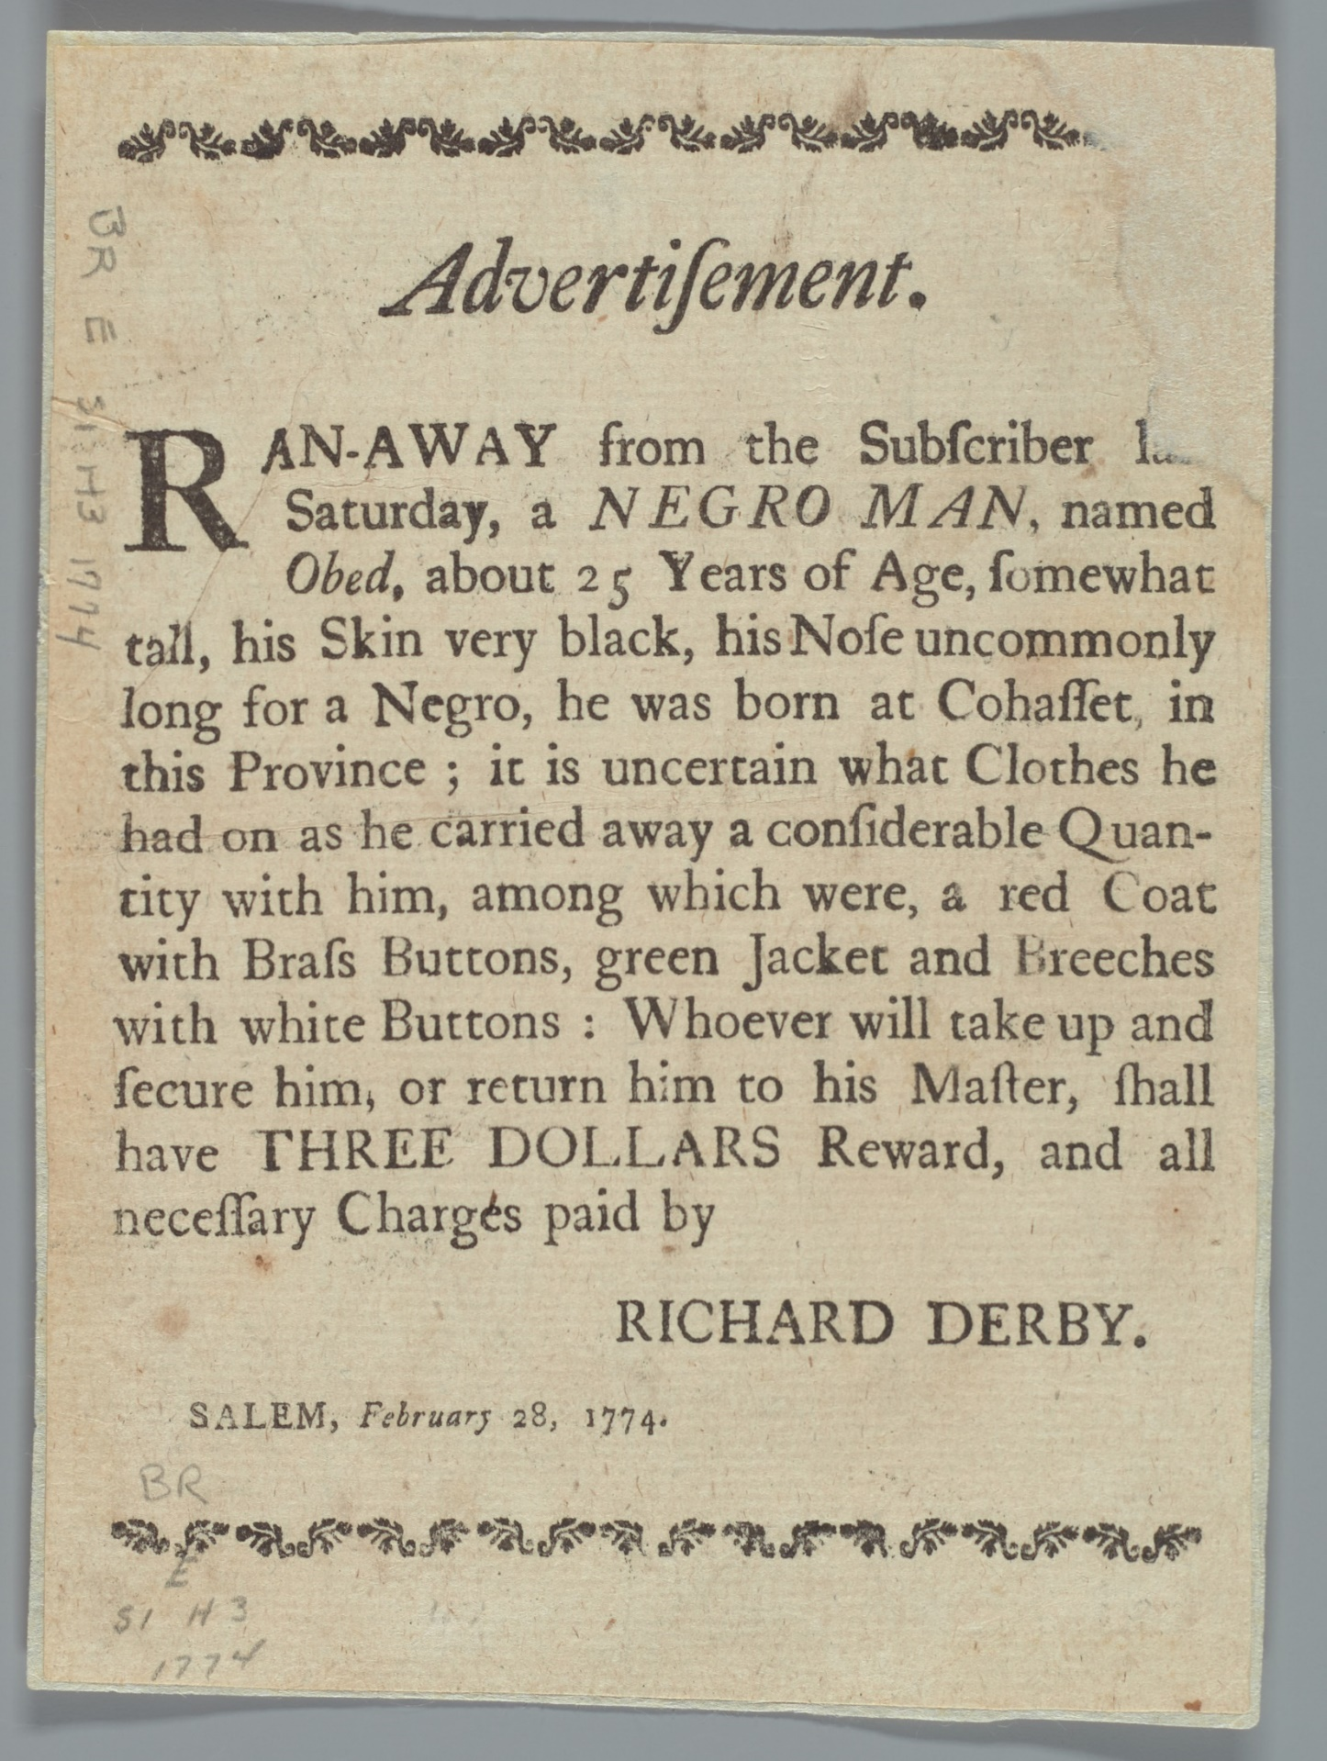
Image Source
Advertisement, 1774, Phillips Library Digital Collections (https://pem.quartexcollections.com).

Supplemental Primary Source Documents

Document C

Mr. Wood’s Affidavit Concerning the Mob at Salem
Original Transcription
Robert Wood was an agent for the British Customs Service in Salem. He witnessed the September, 1768 mob attack on Customs agent, Thomas Row. This is his statement to the Customs Service in Boston describing the attack. He names several Salem merchants who participated in the mob attack, including Richard Derby, his son Elias Hasket, and his son-in-law, George Crowninshield.

Copy of Mr. Wood’s Affidavit concerning the Mob at Salem
I Robert Wood Tide Waiter of his
Majesty’s Customs at Salem & Marblehead
do declare upon Oath that I was present
when Thomas Row was brought up to
the Office in a Cart drawn by the Mob,
who was tarred all over his Shirt and
Trousers and covered with feathers, and
I saw at the Head of the Mob Captain
Lambert, George Crowningshield,
Captain Richard Darbey, Hasket Darbey,
Captain Putingham, and Henry Gardner,
and Joseph Moses, who are the Persons
I took most Notice of at the Head of the
Mob; as Witness my hand.
(Signed) Robert Wood.

Province of the
Massachusetts Bay The above named Robert
Suffolk 9th September Wood made Oath to the Truth
1768 of the Contents of this Writing
by him signed before me.
(Signed) Nath^{l} Hatch Just o^{f}
Peace

Document C
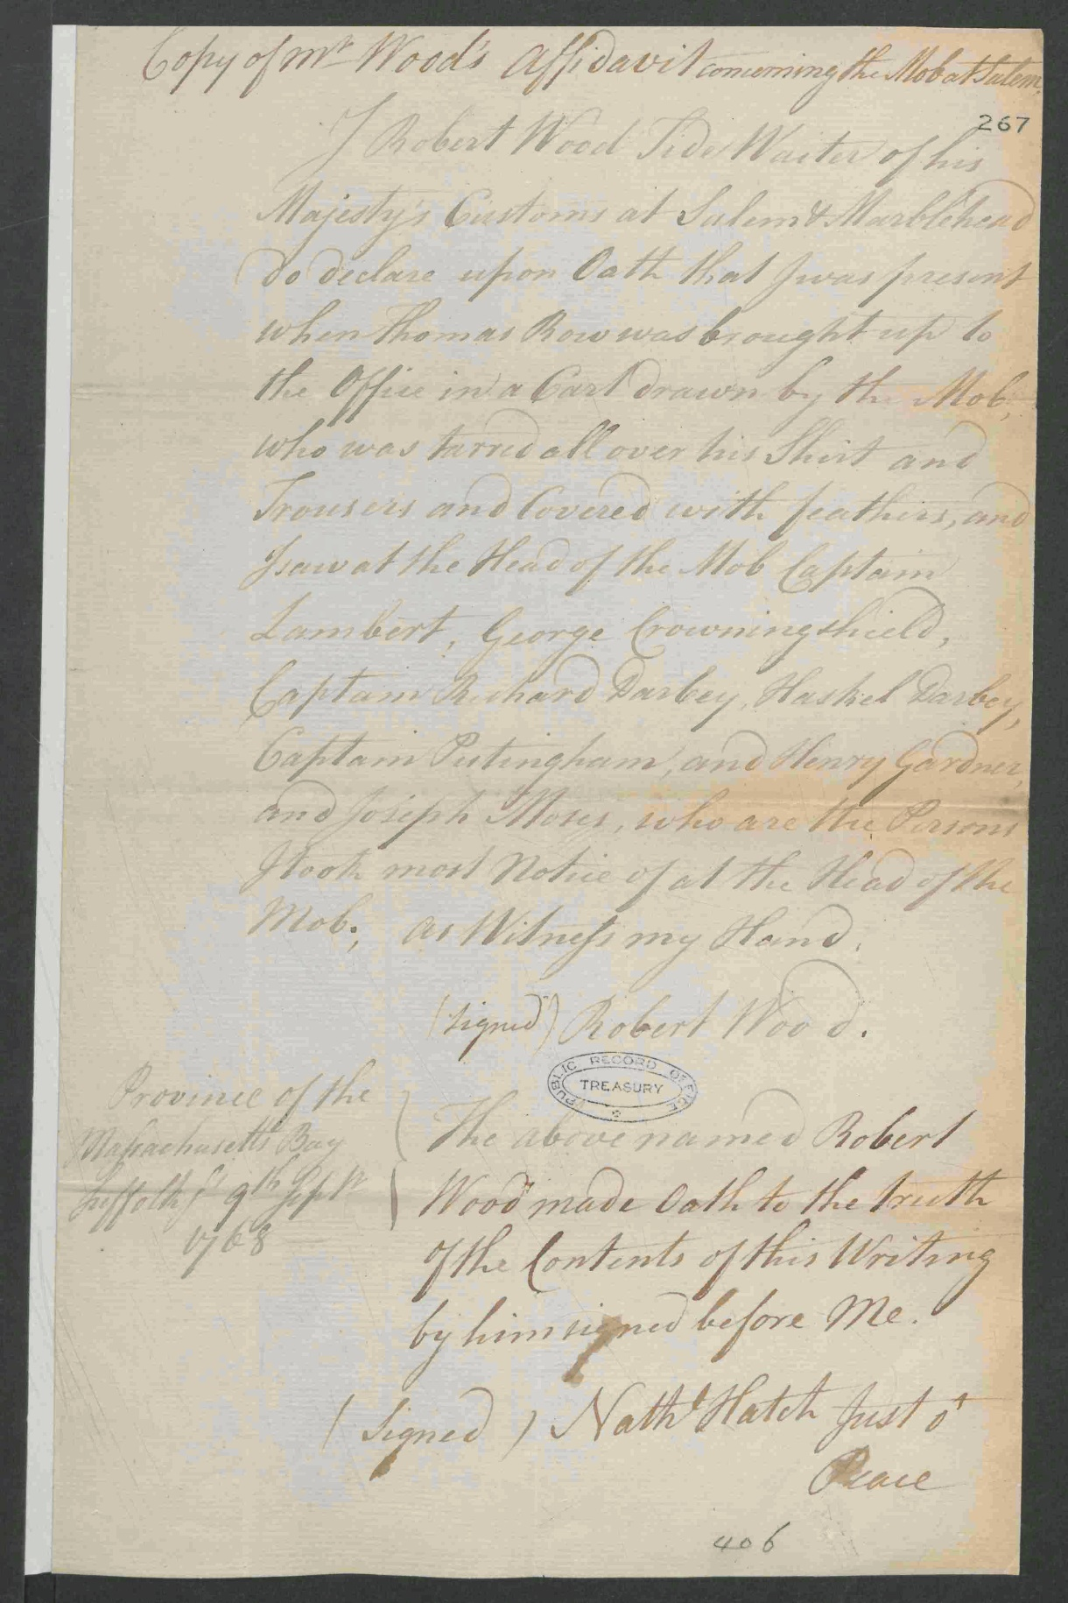
Image Source
The National Archives, United Kingdom. Copy of Mr. Woods's Affidavit concerning the Mob at Salem. September 9, 1768. T 1/465/267-268.

Document D

Cohasset Vital Records: Births
Original Transcription
“Vital records” are records of life events such as birth, death, and marriage. These birth records are from the online database, “Early Vital Records of Massachusetts.” The free database holds information from church records, town records, private records, gravestone inscriptions, and newspaper articles from across Massachusetts.

Cohasset Births
NEGROES.
Asher, s. of Jo and Phillis, negro servants of John Jacobs and J. Bates, Bp. Dec. 29, 1745. C.R.I.
...
...
...
...
...
Obed, s. of Jo and Phillis, bp. Aug. 28, 1748. C.R.I.
Phillys, d. of Jane, negro woman of Jos. Bates, bp. Nov. 17, 1728. C.R.I.
…
…

Document D
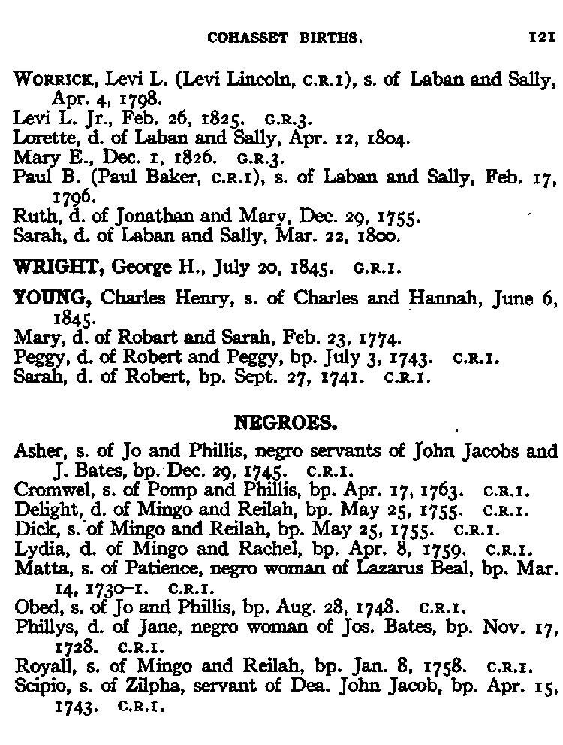

Image Source
Early Vital Records of Massachusetts, From 1600 to 1850. www.ma-vitalrecords.org

